Online Supplement
Table S1. Selection criteria for mechanical thrombectomy
Tab
Time from onset of stroke | Typically up to 6 hours. Up to 24 hours in selected cases using advanced imaging
Pre stroke functional status | No disability or slight disability (mRS ≤ 2)
Stroke severity | Moderate severity or above (NIHSS ≥ 6)
Plain CT | Compatible with ischaemic stroke and no contraindications. ASPECTS score >5 (absence of extensive early ischaemic changes)
CT angiogram | Confirmed LAO (proximal MCA, ICA terminus, or  basilar); good collaterals
mRS=modified Rankin Scale ,NIHSS=National Institutes of Health Stroke Scale, CT=computerised tomography, ASPECTS=Alberta Stroke Programme Early CT Score, LAO=large artery occlusion; MCA=middle cerebral artery; ICA=internal carotid artery

Probability distributions for input parameters in the models
The probability distributions were derived using the R package “fitdistrplus”. The first step was to obtain histograms of the parameter (e.g. waiting time to see the acute stroke team) derived from Sentinel Stroke National audit Programme (SSNAP) or local audit data. Skewness- kurtosis plots (Cullen and Frey Graphs) were drawn and the most likely candidate distributions were tested using goodness of fit statistics (Anderson Darling and others).
Table S1 shows the probability distributions, parameters in the model and data source. Note that some inputs are based on estimates and bootstrapped resampling because of low numbers in our audits. We are continuing our data collection and hope to refine our models as more patients receive thrombectomy assessments in our region.
Table S2: Probability distributions of process variations in the simulation models
Process and model | Probability Distribution | Time period | Distribution parameters | Data source
Stroke onset to arrival time at DSC (all models) | Gamma | WH (8am to 8pm) | shape-3.612290 rate - 2.013986 | SSNAP
Stroke onset to arrival time at DSC (all models) | Gamma | OOH (8pm to 8am) | shape - 3.570325  rate - 1.540188 | SSNAP
Patient arrival (all models) | Exponential | WH and OOH | rate- 0.09357525 | SSNAP
Wait for acute stroke team (all models) | Exponential | WH | lambda - 6 | Local audit
Wait for doctor (all models) | Exponential | OOH | Lambda-3 | Local audit
Acute stroke team assessment time (all models) | Normal | WH | Mean 10 minutes  SD 10 minutes | Local audit
Doctor assessment time (all models) | Normal | OOH | Mean 20 min  SD 18.5 min | Local audit
CT angio decision (all models) | Uniform | OOH | 10-20 min | Estimate
CT and CTA time (all models) | Normal | WH | Mean 21 min, SD 2.5 | Local audit
CT and CTA time (all models) | Normal | OOH | Mean 24 min, SD 3.5 | Local audit
Radiology reporting time (all models) | Normal | WH | Mean 5.5 min, SD 0.72 | Local audit
Radiology reporting time (models A ) | Normal | OOH | Mean 15 min, SD 14.5 | Estimate
NSC referral time (model A) | Uniform | WH | 7-12 minutes | Local audit
NSC referral time (model A) | Uniform | OOH | 7-12 minutes | Local audit
NSC referral time (models B and C) | Uniform | WH and OOH | 3-5 min | Estimate
NSC decision time (all models) | Normal | WH and OOH | Mean 10 min, SD 9 min | Local audit
Call to ambulance arrival (model A and B) | Normal | WH and OOH | Mean 22 min, SD 4.4 | Local audit
Call to ambulance arrival (model C) | Normal | WH and OOH | Mean 18 min, SD 2 | Estimate
Remote network consultation time (model A) | Normal | OOH | Mean 10 min, SD9 | Estimate
Remote network consultation time (model B and C)- includes CTA interpretation | Normal | OOH | Mean 10 min, SD 2.3 | Estimate
Travel time to NSC (all models) | Normal | WH and OOH | Mean 51 min, SD 4 | Estimate from Google maps
DSC= drip and ship centre, WH= within hours, OOH= out of hours, CTA= CT angiogram, NSC= neuroscience centre

Figure S1: Arrival times of all strokes and patients suitable for thrombectomy assessment (NIHSS ≥ 6, pre-stroke mRS ≤ 2, within 6 hours of onset) in a 24 hour period
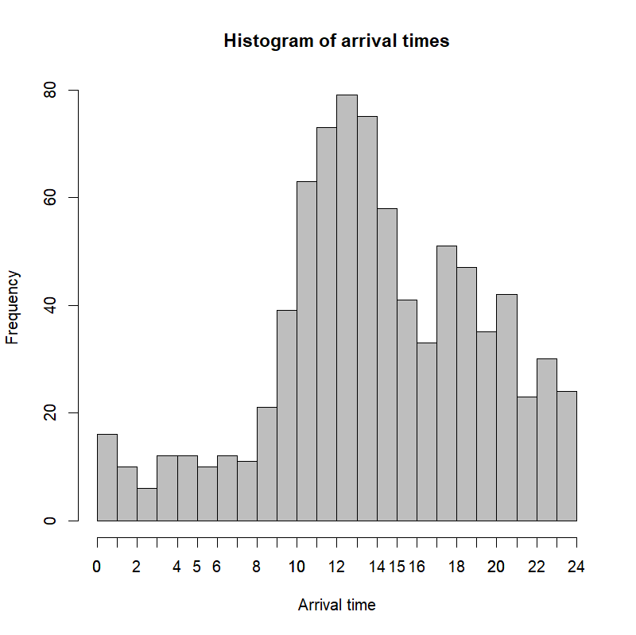 | 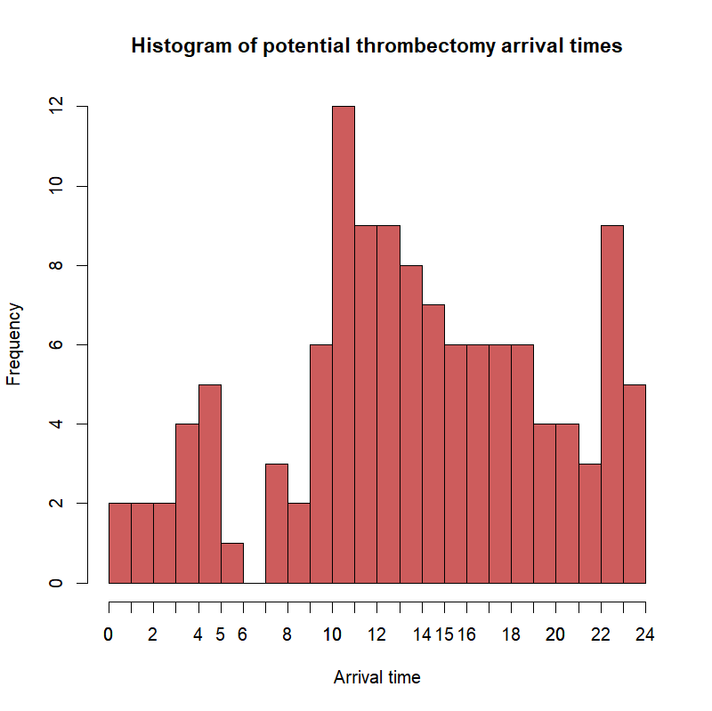

Table S3: Estimated annual numbers of MT patients for all hospitals in the AGWS network
Hospital | Total strokes | Estimated MT (6 hrs) | WH arrivals (8am -5pm | OOH arrivals (5pm – 8am) | Extended WH arrivals (8am-8pm) | OOH arrivals (8pm-8am)
North Bristol Trust (NSC) | 683 | 68 | 33 | 35 | 44 | 24
Bristol Royal Infirmary | 492 | 49 | 25 | 24 | 32 | 17
Gloucester | 823 | 82 | 42 | 40 | 53 | 29
Swindon | 472 | 47 | 24 | 23 | 31 | 16
Bath | 639 | 64 | 33 | 31 | 42 | 22
Salisbury | 383 | 38 | 20 | 18 | 25 | 13
Taunton | 625 | 63 | 32 | 31 | 41 | 22
Weston | 237 | 24 | 12 | 12 | 16 | 8
Yeovil | 390 | 39 | 20 | 19 | 25 | 14
Total | 4774 | 474 | 237 | 238 | 309 | 165
AGWS= Avon, Gloucestershire, Wiltshire, Somerset, WH = within hours, OOH = out of hours, NSC= neuroscience centre
Figure S2: Tornado plot showing the influence of a 20% increase or decrease in several factors on door-in-door-out (DIDO) time (shown as a % change on the x axis) within hours.
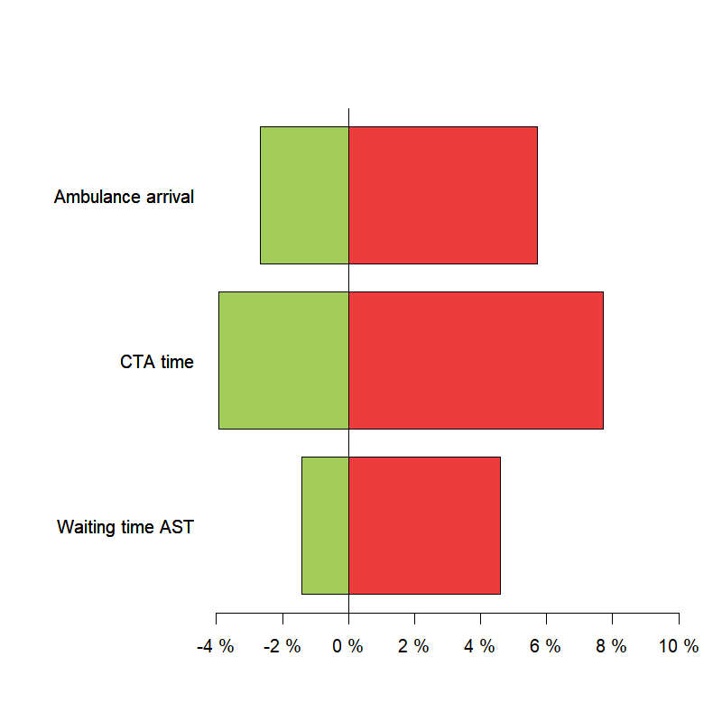

Figure S3: Tornado plot showing the influence of a 20% increase or decrease in several factors on door-in-door-out (DIDO) time (shown as a % change on the x axis) out of hours.
